Step 1) Choose your survey site.
Ringtail Tally
A community ringtail possum count
This is a place where you have seen ringtails before; it may be your own garden or a local park or patch of bush. It must be a specific location and for this reason, we ask that you record ringtails within a defined area, preferably a suburban block sized area.
Step 2) Count the number of ringtails seen during an evening:

- Record the maximum number of ringtails seen within the search area on a single evening.
- Avoid counting the same individual twice. If you see animals at different times in one evening and you are sure they are different individuals, add them together to get a total.
E.g. If you saw 1 large ringtail, followed by 2 smaller ringtails = a total of 3 ringtails.
- If your site is an area of bushland, record the number of ringtails seen within the same area each evening.
- The standard search area is a suburban block (approx. 20 m x 40m). Larger sites are fine, but please estimate the size of the area being searched (40 metres = about 50 paces).
- You may do as many evening surveys as you like.

- Important: Please estimate amount of time spent being ‘on the lookout’ for ringtails during each survey evening from 30mins before sunset to 10pm.
Being ‘on the lookout’ simply means that you are in the search area and if a ringtail turns up, you are likely to see it. (E.g. you might spend 15 minutes outside in the garden and an additional 30 minutes ‘on the lookout’ for ringtails – so that’s 45 minutes total)
- If you don’t see any ringtails on one or all survey evenings, this is still important information – just record zero (0) ringtails for that evening and please still submit your completed data sheet.
Only count an animal if
you are sure it is a ringtail!

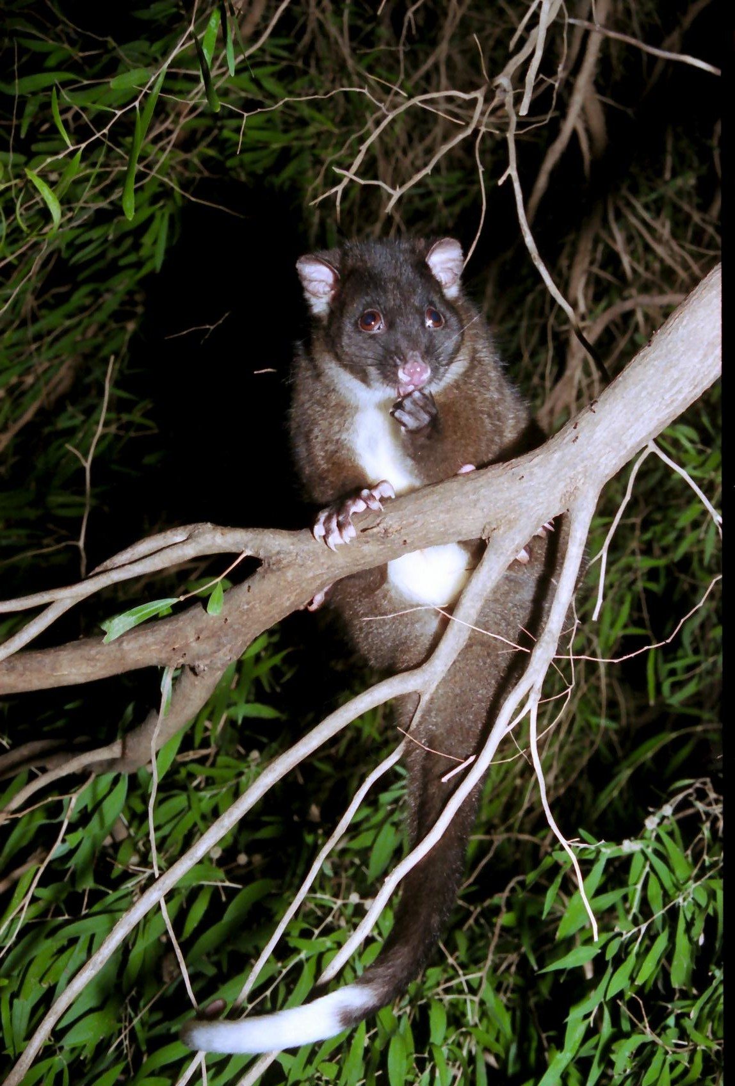
Photo by L. Jackes courtesy City of Busselton

Step 3) Please return completed data sheets
to one of the following:
Email: lyndsey.cox@natureconservation.org.au

Drop into the office: Nature Conservation office,
Community Centre, Tunbridge St,
Margaret River
Please note you are responsible for your own safety while taking part in ringtail surveys. Please dress appropriately for the weather, take someone with you or notify someone of your destination and expected time of return.

Site Information
Name of lead observer(s): | Telephone: | Email:
Survey site address (e.g. residential street address or park name and suburb):

Estimate size of survey site:  Standard search area is a suburban block (approx. 20 metres x 40 metres).  If the block or reserve is large, select a practical survey site within it and estimate area in m²  (40 metres = approx. 50 paces). |  |  | _____m x ____m  or _________m²
Description of survey site: □Suburban garden □Semi-rural house □Park/Sports field □Native bushland
Other: ____________ Tree species ringtails using: Number of trees on your house block:
Pets on property: □Cat □Dog □Other out-door pets: ____________
More location detail (optional) eg. GPS location, nearest crossroad, name and position in park/nature reserve

Western Ringtail Tally

Survey Data

You can do as many evening surveys as you like (from early-April to early-May). If doing more than one evening survey, it is always good to spread them out.
 |  | Evening 1 | Evening 2 | Evening 3 |  | Evening 4 | Evening 5 | Evening 6 | Evening 7 | Evening 8

Date
(dd/mm/yy)

Estimate total time spent looking each evening (min)

Max number of ringtails seen on that evening
Estimate total number of ringtails present at your site across all the surveys (how many different ringtails did you see on your place?). |  |  |  |  | TOTAL_____ |  | If you didn’t see any ringtails, did you see fresh evidence at your site, such as scats, feeding mess or dreys? |  |  | Y/N

Additional Information
Have you seen any dead ringtails this year (inside or outside the survey site)?
Write a number next to each relevant cause of death:
Road kill:___ Cat:___ Dog:___ Fox:___ Swimming Pool:___ Other: ______________________ Total:____
Any signs of breeding (females with young) at your site? (Y/N)___ No. of young seen over survey period: ____
Do you provide food specifically for ringtails? _____ If yes, □ fruit/veg □ oats □ pet food Other: ______________
Have you seen ringtails feeding on other sources such as pet food, fruit trees or native trees on property?
If yes, what? __________________________________________________________
Other comments e.g. weather conditions, location of dead ringtails, other native animals seen during the survey period? (e.g. Owls, quenda, bats)

