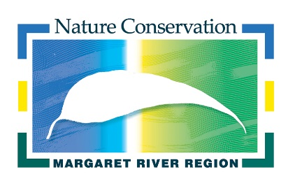

NOMINATION FORM
NATURE CONSERVATION MARGARET RIVER REGION
VOLUNTEER BOARD OF MANAGEMENT

APPLICANT DETAILS

Applicants Name:__________________________________________________________________________________

Address:__________________________________________________________________________________________

__________________________________________________________________________________________________

Postal Address:___________________________________________________________________________________
(if different from above)
_________________________________________________________________________________________________

Telephone Number: Home ____________________________Work ____________________________

Mobile ____________________________

Email address: ____________________________________________________________________________________

Date of Birth: ____________________________________________________________________________________

Occupation: ______________________________________________________________________________________

Declaration:

Under the Incorporations Act 2015 a person is prohibited from sitting on the management committee of an incorporated association (without prior approval by the Commissioner for Consumer Protection) if they:
- are an undischarged bankrupt or their affairs are under insolvency laws;
- have been convicted of an offence in connection with the promotion, formation or management of a body corporate;
- have been convicted of an offence involving fraud or dishonesty punishable on conviction by at least three months or more imprisonment; or
- have been convicted of an offence under Division 3 (the duties of officers provisions) or section 127 (the duty with respect to incurring of debt) of the Act.

I declare that I am eligible to sit on the Nature Conservation Margaret River Region Board of Management with respect to the above and if I am appointed to the Committee will advise should this situation change.

Signature of Applicant: ___________________________________________________ Date ____________________

SELECTION CRITERIA

Please provide a written statement addressing the selection criteria listed below

- A keen interest in, and understanding of, natural resource management;
- Good local knowledge of social, environmental and economic issues in the Margaret River region;
- Preferably local residency in the Margaret River region;
- Experience in coordinating and managing projects and/or business programs;
- Experience and knowledge of governance procedures for incorporated community groups;
- Interpersonal and negotiation skills;
- Communication skills and the ability to use communication networks effectively; and
- Knowledge of and/or experience in project development and sourcing funding for projects.

Please submit your application with a statement addressing the selection criteria and a copy of your Curriculum Vitae to the address below by 4.00pm Monday 12 November 2018.

If necessary, the Nature Conservation Board may seek additional information from applicants, including the names of suitable referees.

HOW TO SUBMIT YOUR NOMINATION

By mail | Nature Conservation Margaret River Region  PO Box 1749  Margaret River WA 6285
Hand delivered | Nature Conservation Margaret River Region  Margaret River Community Resource Centre  33 Tunbridge St, Margaret River
By email | caroline.hughes@natureconservation.org.au
Further information | Caroline Hughes, Nature Conservation Executive Officer 9757 2202 ( Tues, Wed, Thurs)

NOMINATIONS CLOSE: 4.00 PM MONDAY 12 NOVEMBER 2018

